**OSL Assignment 2**

**Roll No. – 33255**

**1) Implement the C program in which main program accepts the integers to be sorted. Main program uses the FORK system call to create a new process called a child process. Parent process sorts the integers using sorting algorithm and waits for child process using WAIT system call to sort the integers using any sorting algorithm. Also demonstrate zombie and orphan states.**

#include <sys/types.h> //Importing required libraries

#include <unistd.h>

#include <stdio.h>

#include <stdlib.h>

#include <sys/wait.h>

void merge(int arr[], int l, int mid, int h) //Function to merge divided array

{

int temp[h-l+1];

int i = l;

int j = mid+1;

int k = 0;

while(i<=mid && j<=h)

{

if(arr[i]<=arr[j])

{

temp[k] = arr[i];

i++;

}

else

{

temp[k] = arr[j];

j++;

}

k++;

}

while(i<=mid)

{

temp[k] = arr[i];

i++;

k++;

}

while(j<=h)

{

temp[k] = arr[j];

j++;

k++;

}

for(int x=l;x<=h;x++)

{

arr[x] = temp[x-l];

}

}

void mergeSort(int arr[], int l, int h) //Merge sort function

{

if(l>=h)

return;

int mid = (l+h)/2;

mergeSort(arr, l, mid);

mergeSort(arr, mid+1, h);

merge(arr, l, mid, h);

}

int main() //main function

{

int choice; //Variable to store choice of user

printf("\n**********MENU**********\n"); //Displaying menu

printf("1.Normal Execution (Sorting) \n");

printf("2.Demonstrate Zombie State \n");

printf("3.Demonstrate Orphan State \n");

printf("\n");

printf("Enter Your Choice : ");

scanf("%d", &choice); //Taking input of choice from the user

switch(choice) //Using switch-case on choice variable

{

case 1: //If choice==1, then normal execution

int arr[5], x;

printf("\n");

printf("Enter Five Integers To Be Sorted \n");

for(int i=0;i<5;i++) //Take five integers as input

{

printf("Enter Integer %d : ",i+1);

scanf("%d", &x);

arr[i] = x;

}

pid_t pid;

pid = fork(); //Call fork() function and store returned value in a variable

switch(pid) //Using switch-case on pid variable

{

case -1: //If pid==-1, then error occured while forking the process

printf("Error In Forking The Process! \n"); //Error occured while forking the process

break;

case 0: //If pid==0, then we are in child process

printf("\n");

printf("Inside Child Process \n"); //We are in the child process

mergeSort(arr, 0, 4); //Sort the given array

printf("Array Sorted By Child Process \n");

for(int i=0;i<5;i++) //Display sorted array

{

printf("%d ",arr[i]);

}

printf("\n");

exit(0);

break;

default: //Else if pid>0, then we are in parent process

printf("\n");

printf("Inside Parent Process \n"); //We are inside parent process

mergeSort(arr, 0, 4); //Sort the given array

printf("Array Sorted By Parent Process \n");

for(int i=0;i<5;i++) //Display sorted array

{

printf("%d ",arr[i]);

}

printf("\n");

printf("Waiting For Child Process To Terminate...... \n \n");

wait(NULL); //Call wait() function to wait till the child has terminated

printf("\n");

printf("Child Process Has Been Terminated \n");

printf("Terminating Parent Process Now \n");

break;

}

break;

case 2: //If choice==2, then demonstrate zombie process

pid_t pid1;

pid1 = fork();

switch(pid1)

{

case -1:

printf("Error In Forking The Process! \n");

break;

case 0:

printf("\n");

printf("Inside Child Process \n");

printf("My Process ID = %d \n", getpid()); //Print PID of child

printf("My Parent's Process ID = %d \n", getppid()); //Print PID of parent

exit(0);

break;

default:

sleep(5); //Putting parent process to sleep so that child process terminates before it

printf("\n");

printf("Inside Parent Process \n");

printf("My Process ID = %d \n", getpid()); //Print PID of parent

printf("Demonstrating Zombie Process \n");

system("ps | grep a.out"); //Displaying current processes

printf("Child Process Is Dead And Has Become A Zombie (defunct) \n\n");

break;

}

break;

case 3: //If choice==3, then demonstrate orphan process

pid_t pid2;

pid2 = fork();

switch(pid2)

{

case -1:

printf("Error In Forking The Process! \n");

break;

case 0:

sleep(2); //Putting child process to sleep so that parent process terminates before it. This makes the child orphan and it is adopted by some other process.

printf("\n");

printf("Inside Child Process \n");

printf("My Process ID = %d \n", getpid()); //Print PID of child

printf("My Parent's Process ID = %d \n", getppid()); //Print PID of parent

system("ps | grep a.out");

printf("This Process Has Been Adopted By Process %d \n", getppid()); //Print PID of parent that has adopted this child process

printf("Its Original Parent Process %d Has Been Terminated \n", (getpid()-1)); //Print PID of original parent

exit(0);

break;

default:

printf("\n");

printf("Inside Parent Process \n");

printf("My Process ID = %d \n", getpid()); //Print PID of original parent

system("ps | grep a.out");

printf("Process %d Is My Child Process \n", (getpid()+1)); //Print PID of child

printf("\n");

break;

}

break;

}

}

**Output**

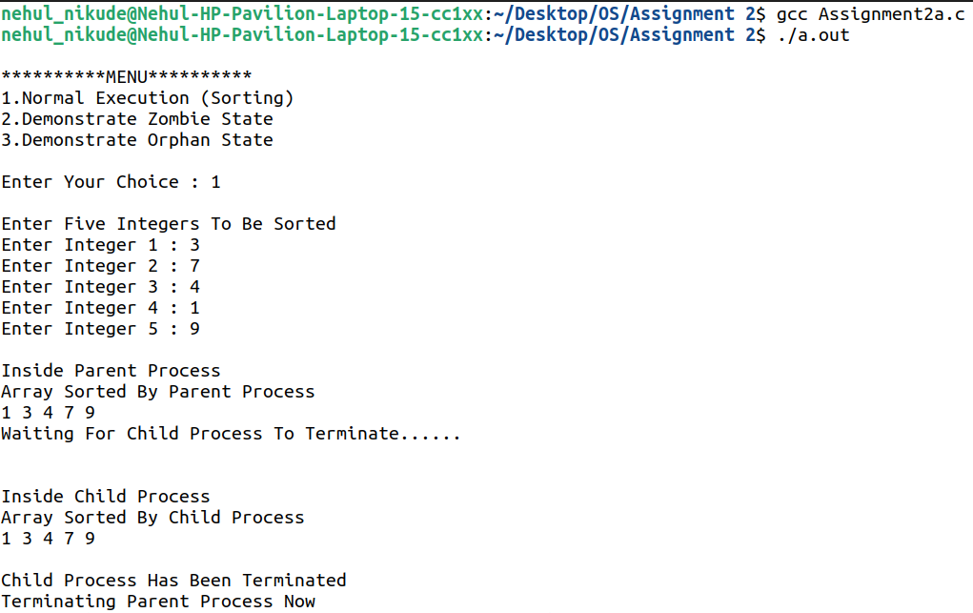

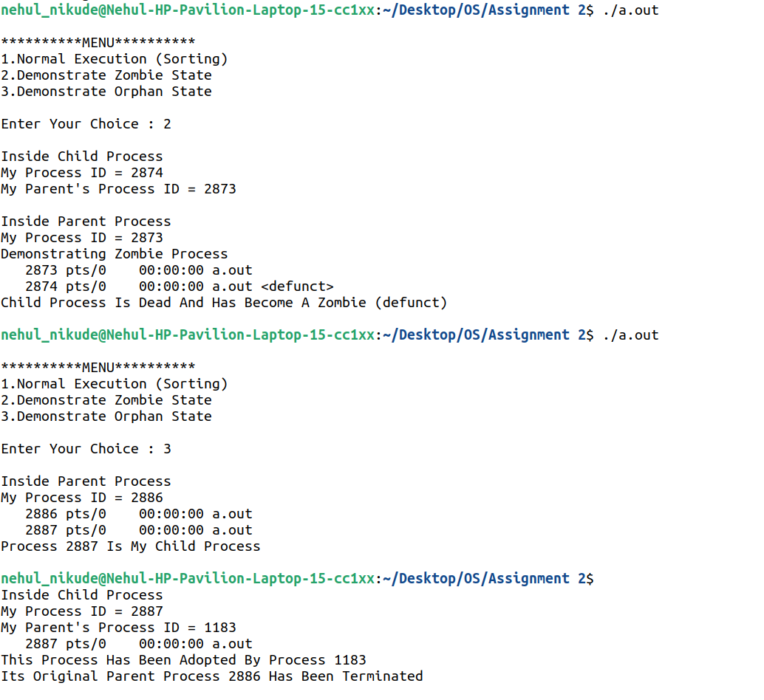

**2) Implement the C program in which main program accepts an integer array. Main program uses the FORK system call to create a new process called a child process. Parent process sorts an integer array and passes the sorted array to child process through the command line arguments of EXECVE system call. The child process uses EXECVE system call to load new program which display array in reverse order.**

#include <stdio.h>

#include <stdlib.h>

#include <unistd.h>

#include <sys/types.h>

#include <sys/wait.h>

void merge(int arr[], int l, int mid, int h) //Function to merge divided array

{

int temp[h-l+1];

int i = l;

int j = mid+1;

int k = 0;

while(i<=mid && j<=h)

{

if(arr[i]<=arr[j])

{

temp[k] = arr[i];

i++;

}

else

{

temp[k] = arr[j];

j++;

}

k++;

}

while(i<=mid)

{

temp[k] = arr[i];

i++;

k++;

}

while(j<=h)

{

temp[k] = arr[j];

j++;

k++;

}

for(int x=l;x<=h;x++)

{

arr[x] = temp[x-l];

}

}

void mergeSort(int arr[], int l, int h) //Merge sort function

{

if(l>=h)

return;

int mid = (l+h)/2;

mergeSort(arr, l, mid);

mergeSort(arr, mid+1, h);

merge(arr, l, mid, h);

}

int main()

{

int arr[5], x;

printf("\n");

printf("Enter Five Integers To Be Sorted \n");

for(int i=0;i<5;i++) //Take five integers as input

{

printf("Enter Integer %d : ",i+1);

scanf("%d", &x);

arr[i] = x;

}

pid_t pid;

pid = fork(); //Call fork() function and store returned value in a variable

switch(pid)

{

case -1: //If pid==-1, then error occured while forking the process

printf("Error In Forking The Process! \n"); //Error occured while forking the process

break;

case 0: //If pid==0, then we are in child process

printf("\n");

printf("Inside Child Process \n"); //We are in the child process

mergeSort(arr, 0, 4); //Sort the given array

printf("Array Sorted By Child Process \n");

for(int i=0;i<5;i++) //Display sorted array

{

printf("%d ",arr[i]);

}

printf("\n");

char** sarr = (char**)malloc(7*sizeof(char*)); //Declaring array of strings

sarr[0] = "./reverse";

sarr[6] = NULL;

int j=0;

for(int i=1;i<6;i++)

{

sarr[i] = (char*)malloc(12*sizeof(char)); //Allocating memory for a string

sprintf(sarr[i], "%d", arr[j++]); //Converting integer to string

}

execv("./reverse", sarr); //Calling exec function to replace current process by reverse program

break;

default: //Else if pid>0, then we are in parent process

printf("\n");

printf("Inside Parent Process \n"); //We are inside parent process

printf("Waiting For Child Process To Terminate..... \n");

wait(NULL);

printf("Execution Of Child Process Has Been Completed \n");

printf("Ending Parent Process Now \n\n");

break;

}

}

**Reverse.c**

#include <stdio.h>

#include <stdlib.h>

#include <unistd.h>

#include <sys/types.h>

#include <sys/wait.h>

int main(int argc, char* argv[])

{

printf("\n");

printf("Inside Reverse Program \n");

printf("Printing Sorted Array In Reverse Order \n");

for(int i=5;i>=1;i--)

{

int x = atoi(argv[i]);

printf("%d ",x);

}

printf("\n\n");

}

